

© ACP ACADEMY 2025
(all rights reserved)
Minor Surgery Service SOP

Contents

Standard Operating Procedure Page 2

Standardised Training program (MSSTP) Page 12

- Introduction Page 13

- Core Training Page 14

- Skills Development Page 16

- Experience Page 17

- Resuscitation Page 18

- Form SDOC1 Page 19

- Form MSTC1 Page 20

Service Process Flowcharts Page 22

- Patient Referral Flowchart Page 23

- Patient Accepted Flowchart Page 24

Patient Consent Form Page 25

Minor Surgery Service

Standard Operating Procedure (SOP)

Purpose

The purpose of this Standard Operating Procedure (SOP) is to establish guidelines and procedures for the delivery of the Minor Surgery Service within [INSERT YOUR ORGANISATION]. This SOP outlines the necessary steps and protocols to ensure safe and effective minor surgical procedures that are carried out in accordance with best practice and regulatory requirements.

- Scope

This SOP applies to all healthcare professionals and administrative staff involved in the provision of Minor Surgery Services within [INSERT YOUR ORGANISATION]. It includes the assessment, planning, and execution of minor surgical procedures, as well as post-operative care and relevant documentation.

- Definitions

- Minor Surgery: A range of surgical procedures performed in the General Practice setting that are relatively simple and low risk under Local Anaesthesia.
- General Practice: A primary care medical practice providing comprehensive healthcare services to registered patients.
- Healthcare Professional: A qualified individual involved in the delivery of healthcare services, such as Doctors, Advanced Health Practitioners, etc.
- Operating Surgeon: A General Practitioner (GP) or Advanced Clinical Practitioner (ACP) with suitable training and experience to perform Minor Surgery.
- Surgical Assistant: Individual employed by the GP practice who can assist with non-clinical work in minor surgery.
- Clinical Administrator: Individual employed by the GP practice who has sufficient knowledge and authority to ensure pre and post-surgical administrative tasks are completed.

- Responsibilities

4.1. The Operating Surgeon (OS)

- Assess patients with complaints about their skin lesion and reach a working clinical diagnosis.
- Where malignancy is suspected to refer patient back to instigating clinician for relevant 2 week-wait pathway.
- Where the lesion is assessed as benign, to assess these patients for clinical suitability and eligibility for minor surgical procedures in General Practice.
- To obtain informed consent from these patients.
- Perform minor surgical procedures within their scope of expertise.
- Ensure provision of any relevant post-operative care and follow-up.
- Ensure Assessment and recording in patient records of post-operative histology report
- Complete the Ardens Minor Surgery Treatment Template for these patients.

4.2. The Clinic Administrator (CA)

- Coordinate the scheduling of minor surgical procedure (see Appendix C) only when approved by the OS.
- Maintain records and documentation related to minor surgery service.
- Ensure that claims for these procedures are submitted to the commissioners in a timely manner.
- Ensure claims for all Personally Administered Items (sutures/local anaesthetic/dressings etc.) are submitted in a timely manner.

4.3. The Surgical Assistant (SA)

- Assist the OS during minor surgical procedures.
- Prepare the patient, surgical field, and instruments.
- Ensure availability of necessary equipment, supplies, and medications (see Appendix A).
- Ensure that post-operative wound care and follow-up is arranged as directed.

- Procedure

5.1. Patient Assessment and Planning

- The referring clinician assesses the patient's eligibility for minor surgery in accordance with the inclusion / exclusion criteria for the Minor Surgery Directly Enhanced Service (DES).
- The referring clinician completes the Ardens “Skin Lesion Minor Surgery Referral” template (fig 5.1.2) on [INSERT PATIENT RECORD SYSTEM] in the patient's record and adds the patient to the "Minor Surgery Awaiting Triage" list.
- Indications for operation for procedures performed under the Minor Surgery Directly Enhanced Service (DES) are Functional Impairment and / or Recurrent Infection. Cosmetic reasons are not covered under the DES.
- The OS assesses the patient's suitability for minor surgery, considering medical history, medication, allergies, and relevant clinical factors.
- OS discusses the procedure, risks, benefits, and alternative options with the patient, including the option not to treat.
- Outcome of this consultation recorded on [INSERT PATIENT RECORD SYSTEM] using the “Skin Lesion Minor Surgery Assessment” template (fig 5.1.6) and adds the patient to the "Minor Surgery Green List (Triaged)" waiting list.
- Patients not appropriate or not wishing to proceed are re-referred to initial referring clinician with reasons documented in patient record.
- OS obtains informed consent from the patient before the procedure.
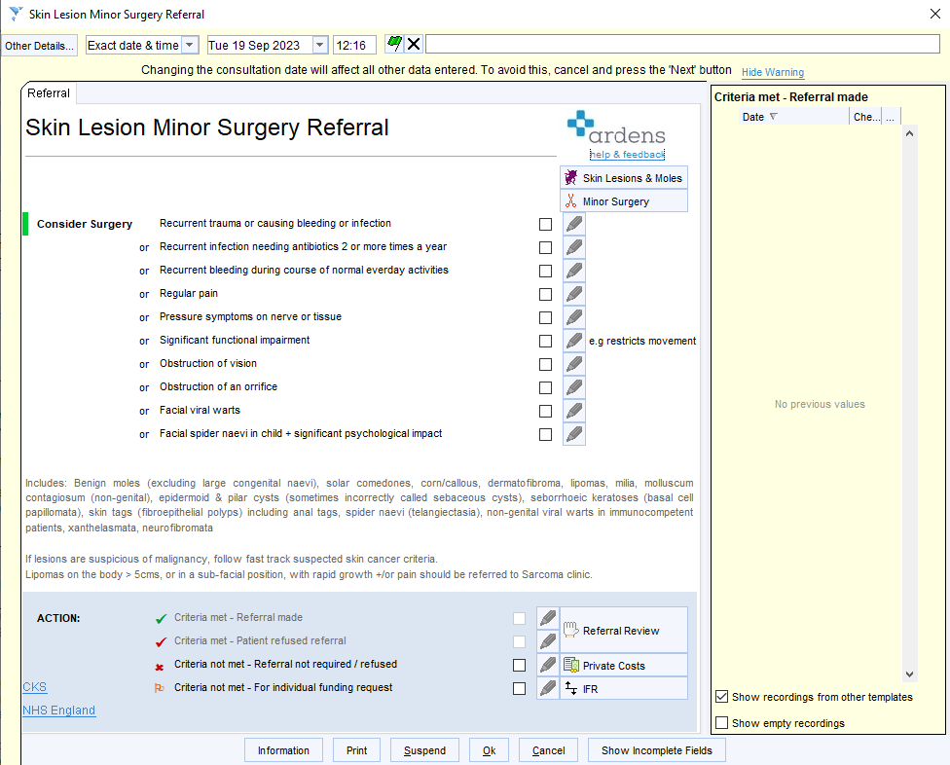
Fig 5.1.2

Fig 5.1.6
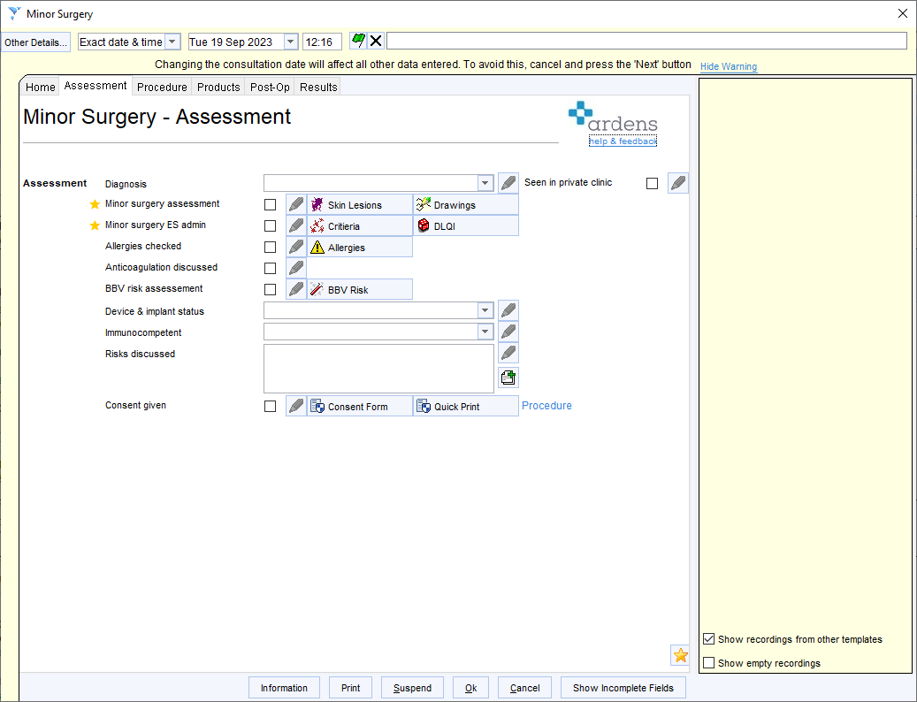
5.2. Pre-operative Preparation

- Prepare the treatment room, ensuring it is well lit and cleaned in accordance with the Infection Control Policy.
- Gather and check the necessary equipment, instruments, and supplies.
- Ensure appropriate infection control measures are in place.
- Prepare the patient by providing instructions, appropriate clothing, and ensuring comfort.

5.3. Surgical Procedure:

- Administer local anaesthesia as required.
- Carry out the surgical procedure using aseptic techniques and following established guidelines.
- Monitor the patient's vital signs during the procedure.
- Manage any unexpected events or complications appropriately.

5.4. Post-operative Care:

- Provide patients with appropriate wound care instructions and post-operative advice.
- Prescribe necessary medications, such as analgesics or antibiotics, if required.
- Schedule follow-up appointments as necessary.
- Document the procedure, products used, post-operative care, and any adverse events in the patient's medical records using Ardens Minor Surgery templates below.
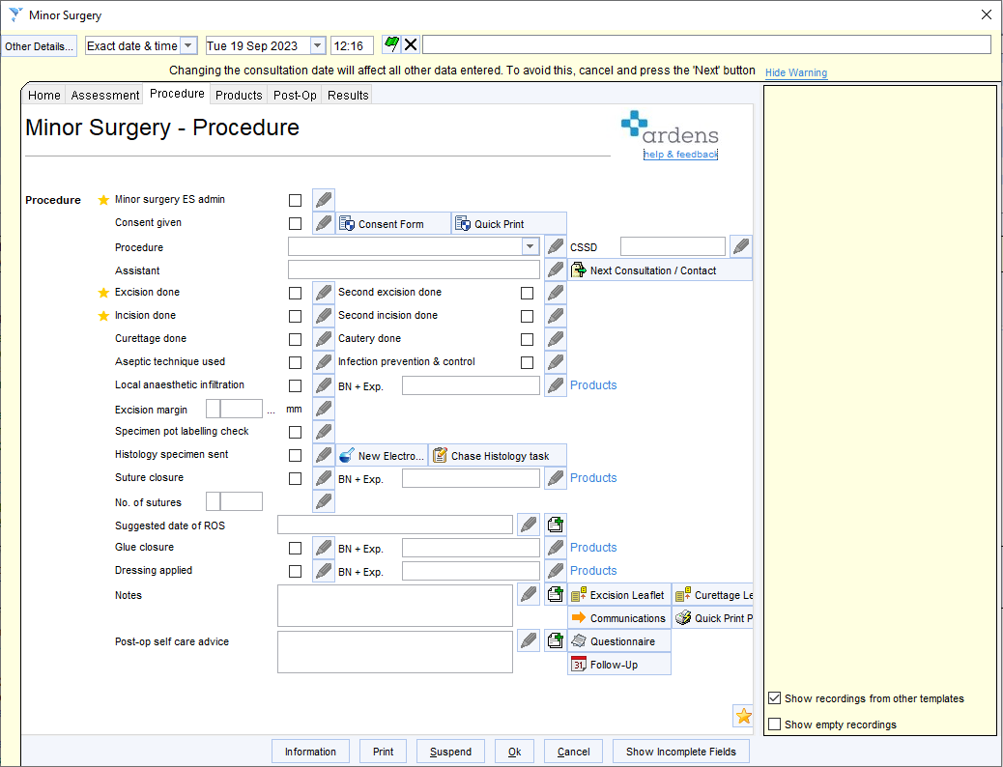

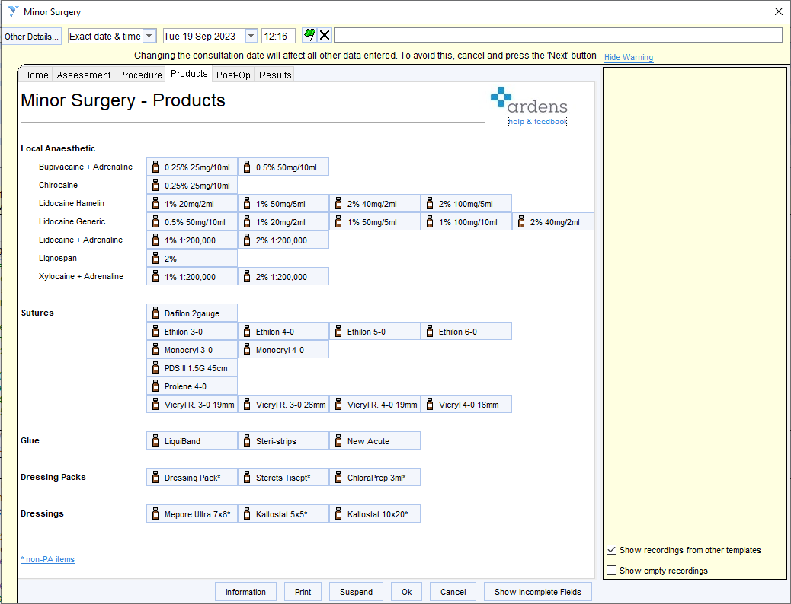
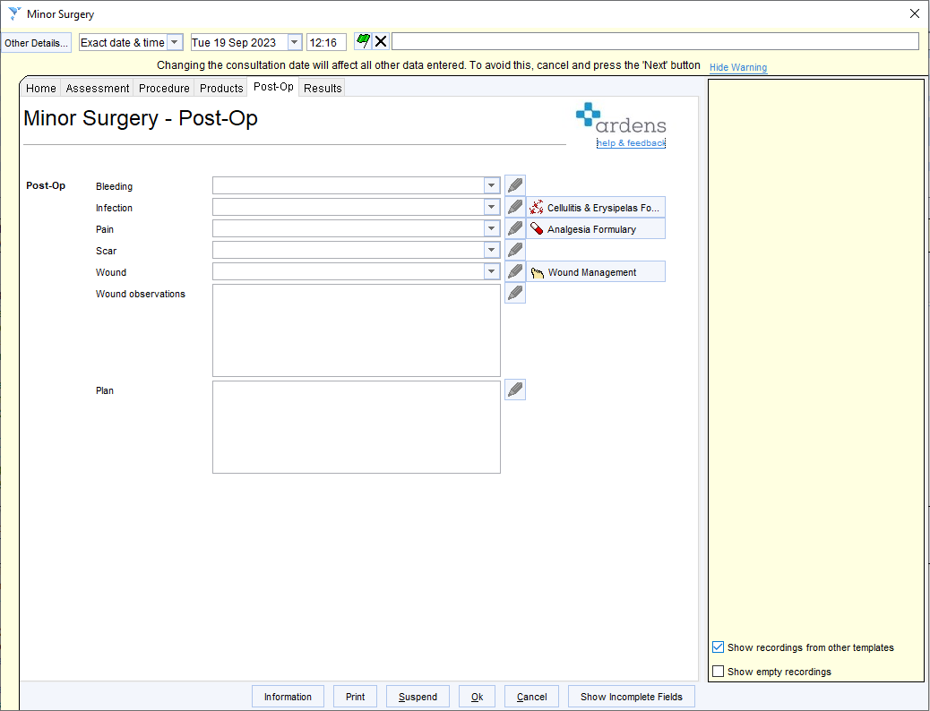

5.5. Equipment and Supplies:

- Maintain an inventory of all necessary equipment, instruments, and supplies.
- Regularly check and ensure equipment is calibrated to ensure accuracy and functionality.
- Dispose of sharps and biohazard waste according to local regulations.
- Restock and reorder supplies as required.

5.6. Quality Assurance and Audit:

- Regularly review and update protocols and procedures to align with current best practice guidelines.
- Conduct regular audits to assess compliance with the SOP and identify areas for improvement.
- Address any identified deficiencies promptly and implement corrective actions.

- Training and Competence

  - All healthcare professionals involved in the delivery of minor surgery services will undergo appropriate training and demonstrate competence in performing minor surgical procedures. Before commencing minor surgery, all non-medical practitioners will complete the Minor Surgery Standardised Training Program (MSSTP), see pp 12-21.

  - Training may include theoretical knowledge, practical skills, and ongoing professional development to ensure up-to date practice.

- Operation Protocol

  - SA checks the room to make sure properly stocked, clean and available.
  - No patient chair in the operating room
  - Family members are not permitted into the operating room unless for consent.
  - If patients are more than 5 minutes late, consider rescheduling the procedure.
  - OS confirms consent with patient (they may hand the consent form in at this time)
  - If the patient has not watched the information video, then consider re-scheduling the procedure.
  - Patient is taken straight to the operating table where the SA assists them to get ready for the procedure.
  - Ask the patient to point out the lesion (DON’T POINT IT OUT FOR THEM)
  - Agree that the SA will be the point of communication between the patient and the OS (distress etc)
  - OS performs surgical procedure (see Appendix B)
  - OS to clean up own sharps and surgical area always
  - OS never leaves operating table.
  - SA may be permitted to apply the dressing.
  - Use [INSERT PATIENT RECORD SYSTEM] template for documenting
procedure.
  - Patient doesn’t leave without a follow up appointment.
  - OS schedules an SMS text message for later that night (around 19:30)
    - “Helllo xxxx, I hope you are doing well and recovering from your procedure today. Just a reminder that information can be found on the information video. (LINK), We look forward to seeing you again.”

Appendix A: List of Equipment Required for Minor Surgery Service in General Practice

Surgical Instruments:

- Strabismus Scissors Curved 11cm
- Disposable guarded No 15 Scalpel
- Adson Toothed Forceps 12cm
- Kilner Needle Holder 12.5cm
- Punch Biopsy 3mm
- Punch Biopsy 5mm
- Ring Curette 7mm
- Dispoable Cautery Pen
- Ultra-fine surgical marker pens
- Formaldehyde Specimen containers
- Hyfrecator 2000 blunt tips
- Hyfrecator 2000 Electrosurgery Machine

Local Anaesthesia and skin preparation supplies:

- Xylocaine 1% solution
- Various Size Syringes
- Orange / Green Needles
- Sterile gauze
- 2% Chlorhexidine in 70% alcohol cleaning solution or Povidone-Iodine 10% w/w cutaneous solution and appropriate receptacle
- Appropriate sharps container for disposal of used needles

Suturing and Wound Closure:

- Sutures (e.g., absorbable, non-absorbable) of various sizes and materials all on a 3/8 curved needle.
- Vicryl / Novosyn (4/0, 5/0) (Round/Tapered Tip Needle) (PURPLE)
- Ethilon / Dafilon (4/0, 5/0) (Cutting / Reverse Cutting Needle) (GREEN)
- Skin closure strips (e.g. Steri-Strips)
- Opsite Spray

Dressings and Wound Care:

- Sterile surgical dressings (e.g., Mepore)
- Sterile gauze pads
- Adhesive tape (e.g., paper tape, hypoallergenic tape)
- Sterile gloves (various sizes)
- Non-sterile gloves
- Disposable aprons

Minor Surgical Procedure Equipment:

- Minor surgery trolley
- Minor surgery lamp
- Minor surgery examination table
- Diathermy unit

Safety Equipment and Supplies:

- Sterile gloves
- Face masks
- Goggles
- Aprons
- Waste disposal containers for sharps and biohazardous waste
- Hand sanitizers
- Hand soap
- Disposable towels

Appendix B: Procedures claimable under the Minor Surgery Directly Enhanced Service (DES)

List of Procedures that can be claimed for under the Minor Surgery DES

- Shave Excision of lesion using a Scalpel
- Full Thickness Elliptical Excision of lesion
- Excision of Epidermal Cyst
- Excision of Lipoma
- Incision and Drainage of Cutaneous Abscess
- Ingrown Toenail Removal

List of Procedures that CANNOT be claimed under the Minor Surgery DES

- Removal of lesion using Curettage
- Treatment of lesion using Cryotherapy
- Removal of lesion using Cautery
- Removal of lesion using Scissors

Appendix C: Scheduling of Minor Surgery List

2+ MONTHS BEFORE SURGICAL LIST

- Minor Surgery List identified on SystmOne by Clinic Administrator (CA) (See 4.1)
- Bulk Text sent out via SMS:
"You are currently on the Waiting List at the practice for Minor Skin Surgery. We are working through this list as fast as possible. Please can you confirm by replying to this message that you still want / require the procedure?”
Patients who no longer require procedure are removed from waiting list.
  - CA bulk message sent to next 24 patients (with an Accurx Self Book link to book their operation at the practice)

2 WEEKS BEFORE SURGICAL LIST

- CA sends SMS / Email to the list:
    - "Your Operation is 2 weeks away and will be carried out at [INSERT PLACE OF PROCEDURE]. Please find a video-link with important information about the procedure below. https://vimeo.com/704542778 Once you have watched the video, please sign the enclosed consent form and bring it along on the day of the procedure. If you don’t watch the video and sign the form, we may have to cancel your procedure on the day."

Link to Video https://vimeo.com/704542778

Embed link for Practice Websites

<iframe src="https://player.vimeo.com/video/704542778?h=cb01f1c221&byline=0&portrait=0" width="640" height="360" frameborder="0" allow="autoplay; fullscreen; picture-in-picture" allowfullscreen></iframe>
<p><a href="https://vimeo.com/704542778">Minor Surgery Patient Information Video</a> from <a href="https://vimeo.com/user110582396">Medical Skills Courses</a> on <a href="https://vimeo.com">Vimeo</a>.</p>

24 HOURS BEFORE SURGICAL LIST

- CA sends SMS / Email to the list:
"We look forward to seeing you tomorrow at [INSERT PLACE OF PROCEDURE] for your minor surgical procedure. Please ensure you have watched the information video prior to the procedure and signed the attached consent form. https://vimeo.com/704542778 If you are unable to make the procedure, please let the practice know ASAP as we may be able to fill your
slot with another patient."

Minor Surgery Service

Standardised Training Program (MSSTP)

Introduction:

In England, health and social care providers are regulated by the Care Quality Commission (CQC) who regulate, inspect, and rate general practices and associated services.⁽¹⁾
The Primary Medical Services Direct Enhanced Service (DES) 2023 framework⁽²⁾ states that all contracted staff undertaking minor surgical procedures must;
- Have appropriate arrangements for infection control and decontamination in premises where surgical procedures are undertaken.
- Take all reasonable steps to provide suitable information to patients about the procedures and;
- Obtain written consent to the surgical procedure before it is carried out, taking all reasonable steps to ensure that the consent form is included in the lifelong medical records held by the patient’s general practitioner.
- All tissue removed by surgical procedures is to be sent for histological examination, unless there are clinically acceptable reasons for not doing so.
- All records relating to all surgical procedures are maintained in such a way that aggregated data and details of individual patients are readily accessible for lawful purposes, and as to facilitate regular audit and peer review.
- Any health care professional who is involved in performing or assisting in any surgical procedure must have;

- Necessary experience, skills and training with regard to that procedure
- Resuscitation skills

In order to comply with the requirements and to provide a standardised framework and demonstrable level of competency across [INSERT NAME OF ORGANISATION], the need for necessary experience, skills and training will be broken down into the following objectives;
- Core Training
- Skills Development
- Experience
- Resuscitation

Each of these objectives will be addressed through the attainment of set outcomes whilst overseen by a named Surgical Mentor (SM). Performing procedures on live patients can be a stressful experience for any practitioner, particularly when the practitioner is a novice⁽³⁾ and so it is important that staff are given the highest level of support and guidance to nurture them whilst still providing an assured level of care and safety for the patient. This will ensure standards are achieved before the clinician is “signed off” as competent to undertake procedures without the presence of the SM.

Core Training:

This will be achieved by the undertaking of THE MINOR SURGERY COURSE ® provided by Medical Skills Courses Ltd. This is a two day NHS England accredited course which was developed in partnership with the Royal College of General Practitioners (RCGP) and the Royal Society of Medicine. The course is delivered via a series of class based lectures as well as supervised hands on practice. The course culminates in the completion of a Direct Observation of Procedural Skills (DOPS) Assessment which is annotated on the course certificate upon successful completion.
Core training will cover the following aspects:
The Minor Surgery Contract:
- Rules & Regulations
- Treatment Room and Facility Requirements
- Equipment, Needles and Sutures
- Support Staff
- Medico-Legal Issues, Consent, and Patient Administration

Patient Assessment:
- Skin Anatomy
- Pigmented Lesion Recognition
- Melanoma Recognition
- NICE Guidelines
- Anticipating Problems
- Reducing Complications

Preparing for the Procedure:
- Planning the Procedure
- Cleaning & Preparing the Skin
- Anaesthetic Administration
- The Ring Block and Field Block Anaesthetic Injection Techniques
- Where to Place Your Incisions
- Measuring & Marking the Surgical Ellipse

Surgical Techniques:

- Excision of Ellipse
- Lipoma Excision
- Epidermal Cyst Excision
- Abscess Incision & Drainage
- Snip Shave & Curettage
- Removal of Ingrown Toenail
- Cryosurgery & Electro-surgery

Wound Closure Techniques:
- Simple Interrupted Sutures
- Deep Dermal Sutures
- Vertical Mattress Sutures
- Horizontal Mattress Sutures
- Subcuticular Sutures
- Achieving Haemostasis

Post-Operative Care

- Histology
- Wound care
- Suture removal
- Follow-up
- Managing Complications
- Audit
Successful completion of this course and associated DOPS will achieve attainment of the Core Training objective.
Course information can be found at:
https://www.medicalskillscourses.com/courses/minor-surgery-course/

Skills Development:

Upon completion of Core Training, the practitioner will move onto the development of key skills by practicing under the direct observation of their designated Surgical Mentor (SM) with live patients. During this phase the practitioner will undertake hands-on experience with guidance from their SM, gaining a further 20 Direct Observation of Procedural Skills (DOPS) assessments incorporating all of the procedures to be encountered under the Minor Surgery DES (shave excision with scalpel, incision and excision of epidermoid / pilar cyst, lipoma and full excision by surgical ellipse). These will be recorded via an individual Online DOPS Log: The format of this log follows the Royal College of Surgeons of Edinburgh DOPS form which can be accessed at:
https://efaidnbmnnnibpcajpcglclefindmkaj/https://www.rcsed.ac.uk/media/417922/dops.pdf.
This method was chosen as studies have established the validity and reliability to support DOPS as an in-training competency assessment tool.⁽⁴⁾

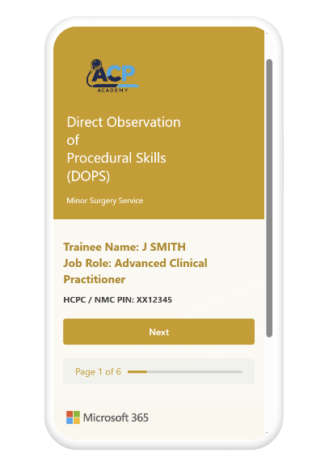
Online DOPS Log:
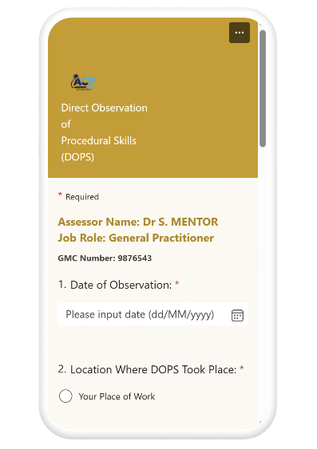
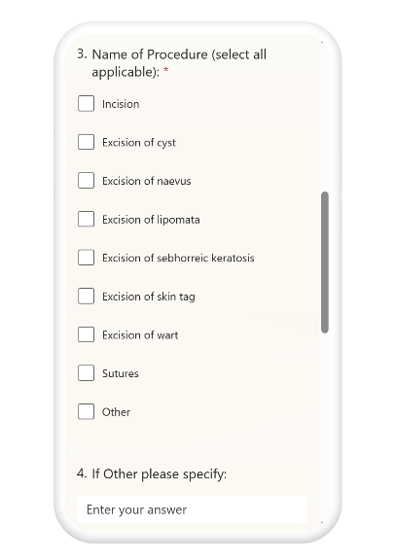

Each surgical practitioner will be provided with their own unique link, generated to give to their SM to record their DOPS on.
Completion of the Skills Development Objective will be achieved upon sign-off by their Surgical Mentor by completing and signing form SDOC1 (appendix A).

Experience:

Experience will be gained alongside skills development but will be undertaken by taking a lead in more of the procedures, with the SM assisting. Experience will be documented by completion of a minor surgery log online. The log must cover at least 20 procedures and include a shave excision with scalpel, incision and excision of epidermoid / pilar cyst, lipoma and full excision by surgical ellipse.

Online Minor Surgery Log:
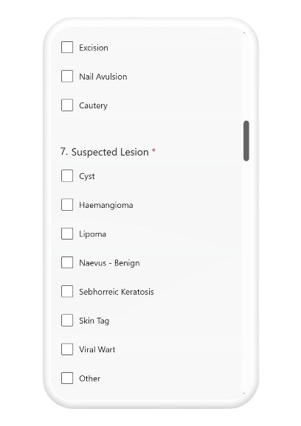
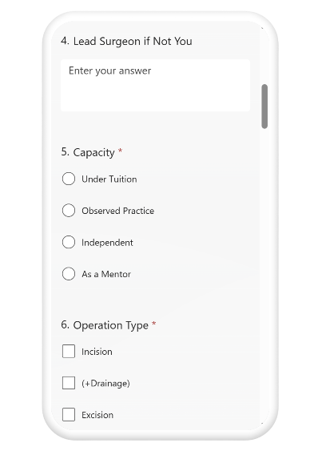
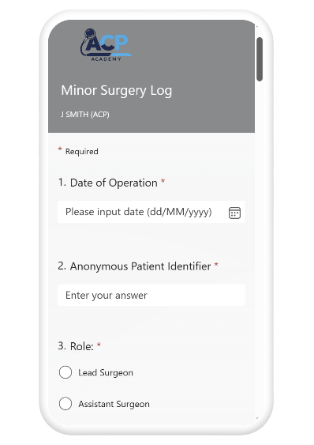

Each surgical practitioner will be provided with a unique personal link, generated to provide access to their individual Minor Surgery Log. This will be maintained beyond the initial 20 surgeries to continue recording their experience. This may also be used to demonstrate continued professional development (CPD) as part of their personal annual appraisal.
The use of surgical logbooks as a reflective and educational tool in training, and for continued learning, have been shown to improve surgical outcomes, patient experiences and reduce healthcare costs.⁽⁵⁾

Resuscitation:

Attainment and revalidation of the practitioner’s resuscitation skills / competency will be achieved via their annual statutory mandatory training or other courses, such as undertaking RCUK ILS training. It is important that the practitioner is aware that allowing this to lapse would place them in breach of the requirements under the Primary Medical Services Direct Enhanced Service (DES) 2023 framework. This would subsequently lead to the revocation of permission to undertake further minor surgery until this competency has been achieved / refreshed.

Completion of Training:

Completion of the [INSERT YOUR ORGANISATION] Minor Surgery Service, Standardised Training Program occurs only upon completion of form MSTC1 (appendix B) by the practitioner’s Surgical Mentor. This form is then retained and remains valid for as long as all of the following objectives are maintained;
- Core Training Completion (or refresher course) within 2 years
- Retention of Form SDOC1
- Continued maintenance of the practitioner’s Minor Surgery Log
- Resuscitation Training within the past 12 months

It is expected that each practitioner maintains the above as part of a portfolio which may be presented upon request by the CQC.

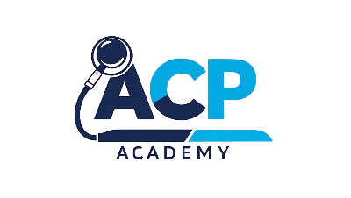
Appendix A:

Form SDOC1

This form is used to record completion of the Skills Development Objective as part of the [INSERT YOUR ORGANISATION] Minor Surgery Service, Standardised Training Program.
As the below practitioner’s Surgical Mentor (SM), I confirm satisfactory direct observation of a minimum of 20 of each type of surgical procedure covering the skills required for minor surgery and have recorded these on the mentee’s online DOPS log.
These include; shave excision with scalpel, incision and excision of epidermoid / pilar cyst, lipoma and full excision by surgical ellipse.
I am satisfied that the below named practitioner has attained a standard of safe practice no longer requiring direct observation.

Surgical Mentor Name: ______________________________ Role: ____________________

Date: ____________________

Mentee Practitioner Name: ___________________________ Role: ____________________

Date: ____________________

Appendix B:

Form MSTC1

This form is used to record completion of the [INSERT YOUR ORGANISATION], Standardised Training Program.

Practitioner Name: ________________________________________

Surgical Mentor: __________________________________________

Objective: | Evidence  Required: | Completion  Date: | SM Sign-off Signature:
Core Training | Course Certificate
Skills Development | Signed Form SDOC1
Experience | Minor Surgery Log  (min 20 complete entries)
Resuscitation | Proof of BLS Training

I am satisfied that the above practitioner has fulfilled all of the criteria as per the [INSERT YOUR ORGANISATION] Minor Surgery Service, Standardised Training Program.

Name: _________________________________________________

Job Title: _______________________________________________

Signature: ______________________________________________

Date of Completion: _______________________________________

References:
⁽¹⁾ Allen T, Walshe K, Proudlove N, Sutton M. Using quality indicators to predict inspection ratings: cross-sectional study of general practices in England. Br J Gen Pract 2020;70(690):e55.
⁽²⁾ NHS England. Primary Medical Services (Directed Enhanced Services) Directions 2023. 2023 31 March.
⁽³⁾ Dehmer JJ, Amos KD, Farrell TM, Meyer AA, Newton WP, Meyers MO. Competence and Confidence With Basic Procedural Skills: The Experience and Opinions of Fourth-Year Medical Students at A Single Institution. Academic Medicine 2013;88(5).
⁽⁴⁾ Siau K, Crossley J, Dunckley P, Johnson G, Feeney M, Hawkes ND, et al. Direct observation of procedural skills (DOPS) assessment in diagnostic gastroscopy: nationwide evidence of validity and competency development during training. Surg Endosc 2020;34(1):105-114.
⁽⁵⁾ Wasson E, Charankumal T, Adam P. DS27: The use of a surgical logbook as a reflective and educational tool to improve learning and patient safety: a retrospective analysis of a decade’s experience in Bristol, UK. Br J Dermatol 2022;187:171.

Minor Surgery Service

Process Flowcharts

Clinician identifies potential patient and adds to Minor Surgery Triage List
Rationale documented in SystmOne by completing
Ardens “Skin Lesion Minor Surgery Referral” template.
(Please see inclusion / exclusion criterior)
Patients meeting 2WW criteria MUST NOT be added to MSS
but immediately referred as per 2WW Pathway by the assessing clinician.
Patients unsuitable or not wishing to proceed are removed from triage list with Task sent to referring clinician to inform patient where necessary.
SystmOne updated to reflect decision by declining OS.
Patients suitable for surgery are added to Minor Surgery Service waiting list and Electronic Patient Record updated to reflect decision by accepting OS.
Go to MSS “Patient Accepted” Flowchart
Minor Surgery Service “Patient Referral” Flowchart
Minor Surgery Inclusion / Exclusion Criteria
List of Procedures that CAN be claimed for under the Minor Surgery DES

- Shave Excision of lesion using a Scalpel
- Full Thickness Elliptical Excision of lesion
- Excision of Epidermal Cyst
- Excision of Lipoma
- Incision and Drainage of Cutaneous Abscess
- Ingrown Toenail Removal
- Steroid Joint Injections

List of Procedures that CANNOT be claimed under the Minor Surgery DES

- Removal of lesion using Curettage
- Treatment of lesion using Cryotherapy
- Removal of lesion using Cautery
- Removal of lesion using Scissors
OS assesses the patient's suitability for minor surgery, considering medical history, medication, allergies, and relevant clinical factors.
OS discusses the procedure, risks, benefits, and alternative options with the patient,
including the option not to treat.
Further to review, decision made regarding suitability for
Minor Surgery. Ardens Template “Minor Surgery Assessment”
completed in Electronic Patient Record.

Patients suitable for surgery are added to Minor Surgery Service waiting list and SystmOne updated to reflect decision by accepting OS.
Go to MSS “Patient Accepted” Flowchart

Minor Surgery Service “Patient Accepted” Flowchart
CA coordinates the scheduling of next minor surgery clinic with availability of Operating Surgeons.
CA collates next batch of accepted patients and adds them to clinic list ensuring OS is named.
Appropriate SMS is sent to list via SMS / Email
Patients suitable for surgery are added to Minor Surgery Service waiting list
by accepting OS
Minor Surgery Completed
OS ensures Pt has follow up appointment booked before Pt leaves clinic.
Care Record updated using Ardens “Minor Surgery” Template
CA ensures claims for procedures are submitted to
commissioners in a timely manner.
CA ensures claims for all Personally Administered Items
(Sutures/Local Anaesthetic/dressings etc.)
are submitted in a timely manner.
CA sends post-surgery SMS to all patients from the day’s list
Post-Surgery (Same Day)
“I hope you are doing well and recovering from your recent procedure. Just a reminder that information can be found on the information video; https://vimeo.com/70454277
We look forward to seeing you again for your follow up.”
24 HOURS BEFORE SURGICAL LIST
"We look forward to seeing you tomorrow at [INSERT LOCATION OF PROCEDURE] for your minor surgical procedure. Please ensure you have watched the information video prior to the procedure and signed the attached consent form. https://vimeo.com/704542778 If you are unable to make the procedure, please let the practice know ASAP as we may be able to fill your slot with another patient."
(Please attach blank consent form again).
2+ MONTHS BEFORE SURGICAL LIST
"You are currently on the Waiting List at the practice for Minor Skin Surgery. We are working through this list as fast as possible. Please can you confirm by replying to this message that you still want / require the procedure? Patients who no longer require procedure are removed from waiting list."
2 WEEKS BEFORE SURGICAL LIST
"Your Operation is 2 weeks away and will be carried out at [INSERT LOCATION OF PROCEDURE]. Please find a video-link with important information about the procedure below. https://vimeo.com/704542778 Once you have watched the video, please sign the enclosed consent form and bring it along on the day of the procedure. If you don’t watch the video and sign the form, we may have to cancel your procedure on the day."
(Please attach blank consent form).
Patients no longer wishing to proceed are removed from waiting list with Care Record updated to reflect decision.

Minor Surgery Service

Patient Consent Form

NHS Commissioning Board

MINOR SURGERY CONSENT FORM
(procedures where consciousness is not impaired)

Patient’s name:

NHS Number / DoB:

Proposed procedure or course of treatment

MRSA screened Yes / No

Statement of health professional

I have discussed the procedure and any available alternative treatments (including no treatment) with the patient. In particular, I have explained:

- The nature of the procedure proposed (including what it is likely to involve)
- The need and intended benefits
- The use of local anaesthesia as necessary
- Postoperative care
- Serious or frequently occurring risks including:

The following leaflet / tape has been provided:
Signed: Date:
Name (PRINT) Job title:
Statement of interpeter (where appropriate)
I have interpreted the information above to the patient/parent to the best of my ability and in a way which I believe s/he can understand

Signed: Date:
Name (PRINT)

Statement of patient/person with parental responsibility for patient

I confirm that the nature, benefits and risks of the proposed treatment have been discussed with me as above and I agree to proceed.

Signed: Date:
Name (PRINT)
Guidance to health professionals (To be read in conjunction with consent policy)
This form:
This form documents the patient’s agreement (or that of a person with parental responsibility for the patient) to go ahead with the investigation or treatment you have proposed. It is only designed for procedures where the patient is expected to remain alert throughout and where an anaesthetist is not involved in their care: for example, for drug therapy where written consent is deemed appropriate. In other circumstances you should use either form 1 (for adults/competent children) or form 2 (parental consent for children/young people) as appropriate.

Consent forms are not legal waivers – if patients, for example, do not receive enough information on which to base their decision, then the consent may not be valid, even though the form has been signed. Patients also have every right to change their mind after signing the form.

Who can give consent:
Everyone aged 16 or more is presumed to be competent to give consent for themselves unless the opposite is demonstrated. If a child under the age of 16 has “sufficient understanding and intelligence to enable him or her to understand fully what is proposed”, then he or she will be competent to give consent for himself or herself. Young people aged 16 and 17, and legally ‘competent’ younger children, may therefore sign this form for themselves, if they wish. If the child is not able to give consent for himself or herself, some-one with parental responsibility may do so on their behalf. Even where a child can give consent for himself or herself, you should always involve those with parental responsibility in the child’s care, unless the child specifically asks you not to do so. If a patient is mentally competent to give consent but is physically unable to sign a form, you should complete this form as usual, and ask an independent witness to confirm that the patient has given consent orally or non-verbally.

When NOT to use this form: (see also ‘This form’ above)
If the patient is 18 or over and is not legally competent to give consent, you should use form 4 (form for adults who are unable to consent to investigation or treatment) instead of this form. A patient will not be legally competent to give consent if:

- they are unable to comprehend and retain information material to the decision.
- and/or they are unable to weigh and use this information in coming to a decision.

You should always take all reasonable steps (for example involving more specialist colleagues) to support a patient in making their own decision, before concluding that they are unable to do so.
Relatives cannot be asked to sign this form on behalf of an adult who is not legally competent to consent for himself or herself.

Information:
Information about what the treatment will involve, its benefits and risks (including side-effects and complications) and the alternatives to the procedure proposed, is crucial for patients when making up their minds about treatment. The courts have stated that patients should be told about ‘significant risks which would affect the judgement of a reasonable patient’. ‘Significant’ has not been legally defined, but the GMC requires doctors to tell patients about ‘serious or frequently occurring’ risks. In addition, if patients make clear they have concerns about certain kinds of risk, you should make sure they are informed about these risks, even if they are very small or rare. You should always answer questions honestly. Sometimes, patients may make it clear that they do not want to have any information about the options but want you to decide on their behalf. In such circumstances, you should do your best to ensure that the patient receives at least very basic information about what is proposed. Where information is refused, you should document this overleaf or in the patient’s notes.

The law on consent:
See the Department of Health’s Reference guide to consent for examination or treatment for a comprehensive summary of the law on consent (also available at www.doh.gov.uk/consent).

This Page Intentionally Left Blank

